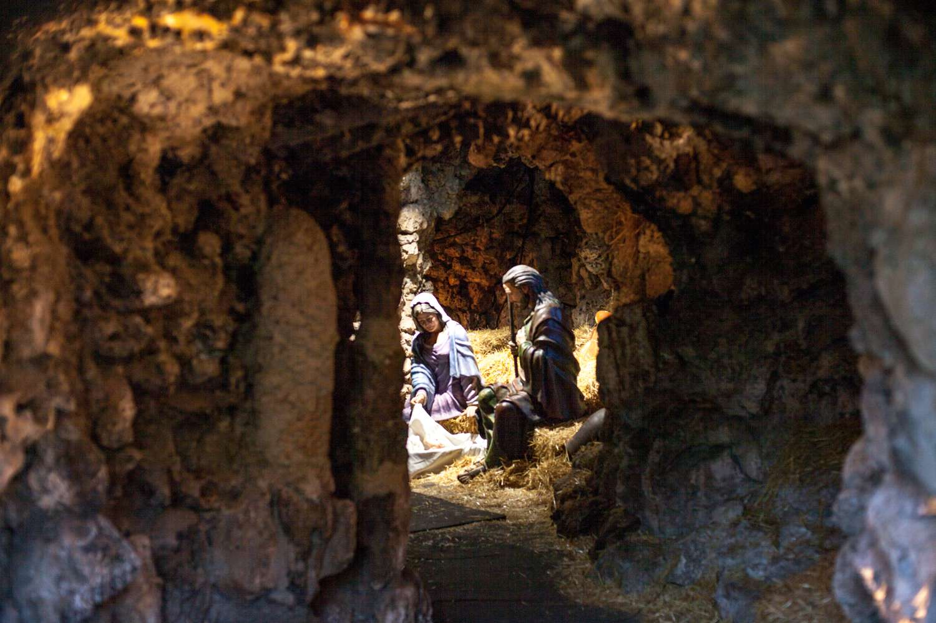
For There Was No Room

A challenging week of travel…
The road, so long and hard.

Carrying only what they needed,
Totally dependent on God.

To the City of David, Bethlehem…
The “House of Bread” - As the prophets foretold.

Every step, trusting…
As Divinity kicked within her womb.

“And while they were there…”
Breaking the silence of the night, “The time came.”

The young couple seeking room...
Only to find none.

Words that sound shameful,
“For there was no room for them in the inn.”

Similarities between the two times?
More common than we realize.

Oh, so like our hearts today…
Where Jesus seeks room.

Many miss the Christ of Christmas,
Totally unaware.

Mary "brought forth..."
A lonely birth.

Our Savior, placed in a manger,
Wrapped in swaddling cloths.

This baby born for sacrifice,
Christ, The Messiah!

Lighting the darkness of our hearts,
Filling it with His Love.

Yes, Lord...
Let there be room.

Merry Christmas
© J Clay Norton, 2022

