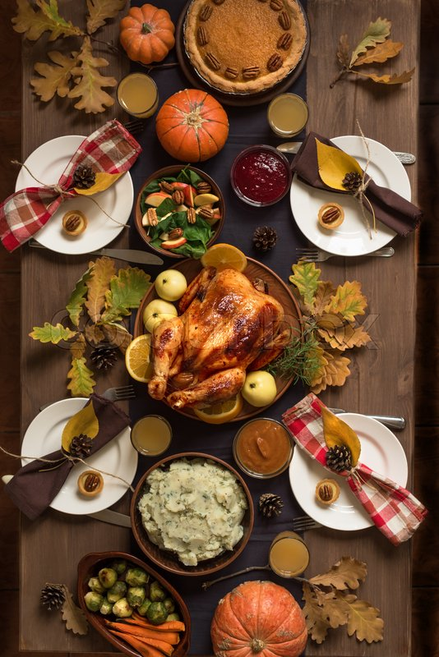
Gathering In Grace

A table set before us, a lavish feast,
A symbol of God’s love that will never cease.
Family and friends gather near,
To celebrate the love, we hold dear.

The prayers we offer, the songs we sing,
Finding God's love in every little thing.
Blessings bestowed from His giving hand,
A bounty of His gift to us, so grand.

In God's sacred grace, we find thanks,
A glimpse of His own love shown on our face.
Flowing down as fresh morning rain,
Restoring hearts, washing away stains.

Grateful for grace that never ends,
God's love, our guide, and our friend.
Every breath, every day we live,
Our purpose is found in the love God gives.

Humble hearts gathered aglow,
Like-minded, kindred spirits grow.
With Thanksgiving in our hearts, we see,
God's boundless love to live eternally free.

Thanksgiving – gathering in grace,
Rejoicing in God's loving embrace.
Beneath Heaven's canopy of celestial hue,
Finding His abundance of love, forever true.

- Happy Thanksgiving -

© J Clay Norton, 2023

