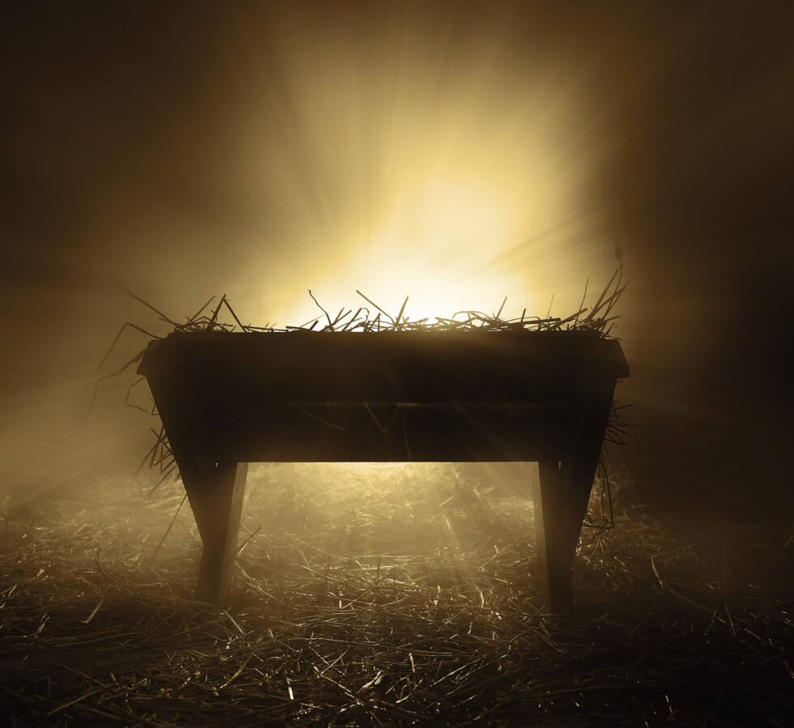
Shekinah in the Manger
The Shekinah stirs…
the Dwelling Presence of God that once thundered on Sinai’s summit,
that once filled the tabernacle and the temple with fire-cloud of holy glory…
Glory, once unapproachable, now soft enough for wise men to behold,
and gentle enough to be cradled in a mother’s arms,
now settling itself into a manger’s glow.

In the hush of that night, Mystery wraps itself in flesh,
the divine Gift laid in the trembling hands of the world.
The hidden, now made visible, the eternal, now made near,
breathes comfort across this shepherd’s field of earth.

The Holy Dwelling has come, the angels sing,
their voices echoing God’s mercy into the night’s wounded world.
Presence made gentle for humanity’s frailty,
that enfolds the fearful in the kindness of His coming.

He arrives as the long-awaited Hope,
the Promised Consolation of Israel, a Light for the nations,
carried by hands of childlike faith and innocence.

The Star of David stoops low and touches earth,
prophecies fulfilled in the first beat of His heart.

He is Majesty wrapped in humility,
Glory wrapped in the fragile form of a child.
He is the Gift no hand could craft,
the peace no exile could imagine.

The Shekinah rests upon Him…
fire without smoke, presence without boundary,
dwelling now in reachable compassion.

He is the Mystery who bends low,
the Majesty who steadies trembling souls,
and still He comes…
consolation for the seeking, comfort for the weary.
Shekinah revealed in the quietness of the manger,
the miracle of God with us,
God near, God here.

Merry Christmas

© J Clay Norton, 2025

